

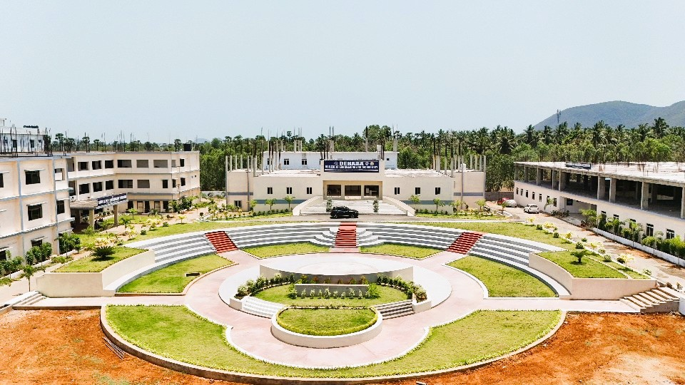

MANDATORY DISCLOSURES

2025-26

BEHARA COLLEGE OF ENGINEERING & TECHNOLOGY
MANDATORY DISCLOSURES
The following information shall be given in the information Brochure besides being hosted on the Institution’s official Website.

Name of the Institution
BEHARA COLLEGE OF ENGINEERING & TECHNOLOGY
Narava,88 th Ward, GVMC,
Visakhapatnam, Andhra Pradesh 530027
MOBILE NO. 9666637234, MAIL ID; beharaenggclg@gmail.com

Name and address of the Trust/Society/Company and the Trustees
Vijaya (Behara) Welfare Educational Society
Narava,88 th Ward, GVMC,
Visakhapatnam, Andhra Pradesh 530027
MOBILE NO. 8919323950, chairman@beharaengg.edu.in

Name and Address of the Vice Chancellor/Principal/Director

Dr.V.SRIDHAR PATNAIK
Behara College of Engineering and Technology
Visakhapatnam -530027
MOBILE NO. 9666637234, EMAIL ID: principal@beharaengg.edu.in

Name of the affiliating University
JNTU GV, GURAJADA VIZIANAGARAM

Governance

- Organizational chart
Enclosed

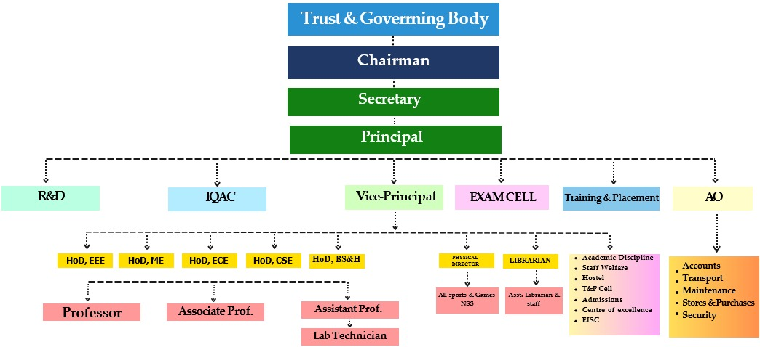

Grievance Redressal mechanism for staff and students
The Institute has a Students' and staff Grievance Redressal Committee. The functions of the Committee are to look into the complaints lodged by any student and judge its merit. The Grievance Redressal Committee is also empowered to look into matters of harassment.
Anyone with a genuine grievance may approach the Grievance Redressal Committee members in person. In case the person is unwilling to appear in self, grievances may be sent in writing and keep in grievance box. Grievances may also be sent through e-mail to the Coordinator of Grievance Redressal Committee or also provided on line grievances mechanism for all the stakeholders in the institute website

Grievance Redressal Committee

S.No | Name of the Committee members | Designation | Department
1. | Dr.V.SridharPatnaik | Principal | MECH
2 | Mrs Y Pavani Phy | Asst.Prof, | BS&H
3 | Dr B Devi | HoD, BS&H | BS&H
4 | Mrs V Sukanya | Distinguished Member | CSE
5 | Mrs K G S Vasantha | Asst.Prof, BS&H | BS&H
6 | Mrs KS P Keerthi | Asst.Prof, CSE | CSE
7 | Mrs S Nikitha Reddy | Asst.Prof,Maths | BS&H
8 | Mrs J Vijaya Lakshmi | Librarian | BS&H
9 | Ms O Lavanya | Physical Director | BS&H
10 | Ms Ch Padma Pooja | Student,CSE | CSE
11 | G.Reshma | Student,CSE | CSE
  - . Online Grievance Redressal Mechanism established in the institute website:Yes
  - . Details of Grievance Redressal Committee in the Institution and OMBUDSMAN - Provided

- Discipline and Anti-Ragging Committee (Anti Ragging Cell/Anti Ragging Squad)

S.No | Name of the Committee members | Designation | Department
1. | Dr.V.Sridhar Patnaik , Chairperson | Principal | Principal MECH
2 | Mr. G.Srikanth  Co-ordinator | Asst. Professor | HoD ECE
3 | Dr.B.Devi , Member | Asso.Professor | HoD BS&H
4 | Mr.CH.Narayan , Member | Asso.Professor | HoD CSE
5 | Mr.CH.Govinda Raju, Member | Asst.Professor | HoD EEE
6 | Mr.D.Kiran Kumar, Member | Asst.Professor | HoD Mech
7 | Mrs.Y.Pavani, Member | Asst.Professor | BS&H
8 | Mr.A.Praveen, Member | PH.D | H&BS
9 | Mr.Rakshit Kumar Pandey, Member | Asst.Professor | Mech
10 | Two parents, Members  - G Raja Rao  Y Mahesh
11 | Two Students from fresher  and senior, Members  - D Siddartha  - B Renukha | Students  Branch | I YR.Mech  II YR,CSE
12 | Mrs. G.Janaki |  | Pendurthi  Police Station  9885291889

- Establishment of Internal Committee (IC)
Internal Committee (IC)/Women Empowerment Cell (WEC) Committee

S.No | Name of the Committee members | Designation | Department
1 | Dr.V.Sridhar Patnaik | Asst. Professor | MECH
2 | Mrs Y Pavani | Professor | H& BS
3 | Dr A Hindumathi | Asst. Professor | Principal,B Sc Nursing
4 | Dr B Devi | Asst. Professor | H& BS
5 | Mr G Srikanth | Asst. Professor | ECE
6 | Dr G Berth Ramesh | Asst. Professor | H& BS

7 | Mrs S Nikitha Reddy | Asst. Professor | H& BS
8 | Mr R Praveen | Asst. Professor | CIVIL
- Establishment of SC/ST Committee

S.C & S.T COMMITTEE
S.No | Name of the Committee members | Designation | Department
1 | Dr. V. Sridhar Patnai | Principal | MECH
2 | Dr. B.Devi | Associate Professor | H& BS
3 | Dr. G.B.Ramesh | Professor | H& BS
4 | Mr Ch. Govinda Raju | Asst. Professor | EEE
5 | R. Anitha Priya | Student | Student
6 | M. Sham | Student | Student
7 | V. Sindhu | Student | Student
8 | Ch. Padma Pooja | Student | Student

- Internal Quality Assurance Cell

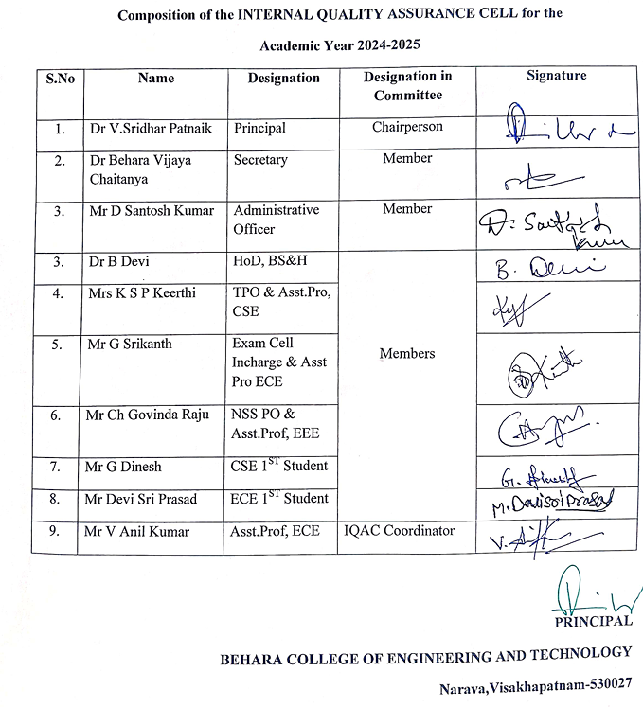

ix Equal Opportunity Cell/ Skill Development Cell/ Internship Cell:NIL

  - Programmes:
- Name of Programmes approved by AICTE
Engineering & Technology – B.Tech,
- Name of Programmes Accredited by NBA NIL
- Status of Accreditation of the Courses: NIL

- Total number of Courses:
- For each Programme, the following details are to be given (Preferably in Tabular form):
Cut off ranks: As per APSCHE CET Test Phase wise counseling

S.NO | NAME OF THE COURSE | INTAKE | DURATION
1 | B.TECH -MECHANICAL ENGINEERING | 30 | 4 YEARS
2 | B.TECH-ELECTRICAL & ELECTRONICS  ENGINEERING | 30 | 4 YEARS
3 | B.TECH- ELECTRONICS AND  COMMUNICATION ENGINEERING | 60 | 4 YEARS
4 | B.TECH-COMPUTER SCIENCE & ENGINEERING | 180 | 4 YEARS
5 | B.TECH- COMPUTER SCIENCE &  ENGINEERING ( DATA SCIENCE) | 60 | 4 YEARS
- Fee (as approved by the state government):
- For B.Tech courses Rs 43,000/-
- Name and duration of Programme(s) having Twinning and Collaboration with Foreign University(s) and being run in the same Campus along with status of their AICTE approval. If there is Foreign Collaboration, give the following details, if any:--- NA
- Nature of Collaboration NA
- Complete details of payment a student has to make to get the full benefit of Collaboration
- For each Programme Collaborated provide the following: NA
- Programme Focus:---
- Number of seats:-----
- Admission Procedure: ----
- Whether the Collaboration Programme is approved by AICTE? If not whether the Domestic/ Foreign University has applied to AICTE for approval: NA

Faculty:
- Course/Branch wise list Faculty members:
S.NO | Branches /Courses | Doctorates | Prof. | Assoc. Prof | Asst. Prof | Total
1 | Computer Science & Engineering (B.Tech) | 1 | 1 | 2 | 15 | 19
2 | Computer Science & Engineering (DS) | 0 | 0 | 0 | 4 | 4
3 | Electronics & Communications Engineering  (B.Tech) | 1 | 0 | 1 | 7 | 9
6 | Electrical & Electronics Engineering  (B.Tech) | 0 | 0 | 0 | 4 | 4
7 | Mechanical Engineering (B.Tech) | 1 | 1 | 0 | 4 | 6
 | TOTAL | 3 | 2 | 3 | 34 | 42

- Permanent Faculty : 39
- Adjunct Faculty: NIL
- Permanent Faculty: Student Ratio: B. Tech : 1:20
- Profile of Vice Chancellor/Director/Principal/Faculty:
- Name: Dr. V.Sridhar Patnaik, Principal
- Date of Birth : 02-07- 1969
- Unique ID: BCET-T-001., AICTE ID Mo: 1-7794764506
- Education Qualifications: M. Tech., Ph. D
- Work Experience: 25 years
- Teaching/ Research/ Industry/ Others: Industry: years and Teaching: years
- Area of Specialization: Thermal Engineering
- Courses taught at Under Graduate Level: UG and PG
- Research guidance (Number of Students): NIL
- No. of papers published in National/International Journals/Conferences: 8
- Master (Completed/Ongoing): Completed
- Ph.D. (Completed/Ongoing): Completed
- Projects carried out:
- Patents (Filed & Granted): Filed: 4 and granted:
- Technology Transfer: ICT Tools
- Research Publications (No. of papers published in National/International Journals/Conferences): 3
- No. of Books published with details (Name of the book, Publisher with ISBN, year of publication, etc.): Three (3)

LIST OF PUBLICATIOONS IN NATIONAL AND INTERNATIONAL JOURNALS

LIST OF PUBLICATIOONS IN NATIONAL AND INTERNATIONAL CONFERENCES
LIST OF PATENTS

Fee:
- No. of Fee waivers granted with amount : 186., 79 Lakhs
- Number of scholarship offered by the Institution, duration and amount: NIL

Admission
- Number of seats sanctioned with the year of approval

S.No | Course/Branch | Sanctioned  strength | Year of start/  Approval
2 | B.TECH-ELECTRICAL & ELECTRONICS  ENGINEERING | 30 | 2024
3 | B.TECH- ELECTRONICS AND  COMMUNICATIONS ENGINEERING | 60 | 2024
4 | B.TECH-COMPUTER SCIENCE &  ENGINEERING | 180 | 2024
6 | B.TECH- COMPUTER SCIENCE &  ENGINEERING ( DATA SCIENCE) | 60 | 2024
17 | B.TECH-MECHANICAL ENGINEERING | 30 | 2024
- Number of Students admitted under various categories each year in the last three years

Course | 2024-25 |  |  |  |  | 2025-26
 | GEN | SC | ST | OBC | TOT | GEN | SC | ST | OBC | TOT
B.Tech

General includes EWS and Minority

- Number of applications received during the year for admission under Management Quota and number admitted
- Under M.Q , No of applications: 41
- Number o students admitted under M.Q:41

S. No | courses | No. of seats allotted through  Category-B (M.Q)
1 | B.Tech | 37
2 | B.Tech- LE | 19

Admission Procedure:
- Mention the admission test being followed, name and address of the Test Agency/State Admission Authorities and its URL (website)
S.No | Programmes | Test | URL (website)
1 | B.Tech | EAPCET, A.P | cets.apsche.ap.gov.in
- Number of seats allotted to different Test Qualified candidate separately (AIEEE//JEE/ CET (State conducted test/ University tests/ CMAT)/ Association conducted test etc.)
B.Tech -., B.Tech –LE= .
S. No | courses | No. of seats  allotted through CETS (C.Q)
1 | B.Tech | 170
2 | B.Tech- LE | 18
- Calendar for admission against Management quota seats:

S.No | Calendar for admission against Management quota seats:
1 | Last date of request for applications | B.Tech-11/10/25 B.Tech –LE : 2/10/25
2 | Last date of submission of applications | B.Tech-17/10/25  B.Tech –LE : 3/10/25

3 | Dates for announcing final results | As per APSCHE
4 | Release of admission list (main list and waiting list  shall be announced on the same day) | As per APSCHE
5 | Date for acceptance by the candidate (time given  less than 15 days) | As per APSCHE  proceedings
6 | Last date for closing of admission & Starting of the Academic session  The waiting list shall be activated only on the expiry of date of main list | B.Tech- 4/8/25 B.Tech –LE : 4/8/25
7 | The policy of refund of the Fee, in case of  withdrawal, shall be clearly notified | As Per APSCHE  Guidelines

Criteria and Weightages for Admission:
- Describe each criterion with its respective weightages i.e. Admission Test, marks in qualifying examination etc.
As Per APSCHE Guidelines
- Mention the minimum Level of acceptance, if any

- Mention the cut-off Levels of percentage and percentile score of the candidates in the admission test for the last three years:
As per CET Rankings and APSCHE Criteria and wieghtages for admission

- Display marks scored in Test etc. and in aggregate for all candidates who were admitted: As Per Rankings of CET tests

18.13. List of Applicants:
List of candidates whose applications have been received for open seats. List of candidates who have applied along with percentage and percentile score for Management quota seats (merit wise)/ submitted to APSCHE for UG

List of MQ Applications - 41 Candidates - Admissions 2025
S  No | Student Name | Course applied
1 | VADDADHI PADMAVATHI | B.TECH,CSD
2 | BODDETI MOUNIKA SRI LAKSHMI | B.TECH,CSD
3 | BANDARU KARTHIK | B.TECH,CSD
4 | PEDADA MANIKANTA | B.TECH,CSD
5 | NAKKA NITHANYA PAUL | B.TECH,CSD
6 | BHUMI REDDI NANI | B.TECH,CSE
7 | BAI LAVANYA | B.TECH,CSE
8 | PUKKALLA YELLMAJI | B.TECH,CSE
9 | CHINTALAPUDI YAGNESH KUMAR | B.TECH,CSE
10 | BASURU THANISH RITHWIK | B.TECH,CSE

11 | PODUGU RANJITH | B.TECH,CSE
12 | KARRI VENKATA SAI | B.TECH,CSE
13 | NAGAVARAPU HEMANTH | B.TECH,CSE
14 | SHINAGAM KIRAN KUMAR | B.TECH,CSE
15 | GEDELA HARSHA VARDHAN | B.TECH,CSE
16 | VABBINA JANSI | B.TECH,CSE
17 | PEDIREDLA YAMINI | B.TECH,CSE
18 | MOLLETI JASWANTH | B.TECH,ECE
19 | BIKASH MAHA RANA | B.TECH,ECE
20 | GAMPA SURYA TEJA | B.TECH,ECE
21 | GORLE LAVANYA | B.TECH,ECE
22 | PADALS SAI SURYA TEJA | B.TECH,ECE
23 | SK ZISHAN ALI | B.TECH,EEE
24 | D.Gowri Sankar Varma | B.TECH,EEE
25 | R.Harsha Vardhan | B.TECH,EEE
26 | SUGALA SIVA VARA PRASAD | B.TECH,EEE
27 | BOKAM YASASWINI | B.TECH,EEE
28 | TADELA VAMSI KRISHNA PRASAD | B.TECH,MECH
29 | KARRI HARI RAM SAI | B.TECH,MECH
30 | PALISETTI SHANMUKHA RAO | B.TECH,MECH
31 | SHAIK KHADAR BABA | B.TECH,MECH
32 | KOLLU VANAMA JAYA | B.TECH,MECH
33 | KAMILLI VIJAYA KUMAR | B.TECH,MECH
34 | SHIV NARAYAN VISHWAKARMA | B.TECH,MECH
35 | VAKADA DILEEP KUMAR | B.TECH,MECH
36 | MOHAMMED KAMAL | B.TECH,MECH
37 | KOLLURU AGAM ROSHAN | B.TECH,MECH
38 | BAVIRI SURI DEMUDU | B.TECH,MECH
39 | MUNASA SAI GUNA VARUN | B.TECH,.MECH
40 | CHALAPAKA AJAY | B.TECH.,MECH
41 | PANCHIREDDI SANTOSH KUMAR | B.TECH.,MECH

18.14 Results of Admission under Management seats/Vacant seats:
- Composition of selection team for admission under Management Quota
MQ seats also finalized by APSCHE for UG

- List of candidate who have been offered admission

List of MQ Admitted Candidates - 41 - Admissions 2025
S  No | List of MQ Admitted Students | Course | Branch
1 | VADDADHI PADMAVATHI | B.Tech. | CSD
2 | BODDETI MOUNIKA SRI LAKSHMI | B.Tech. | CSD
3 | BANDARU KARTHIK | B.Tech. | CSD
4 | PEDADA MANIKANTA | B.Tech. | CSD
5 | NAKKA NITHANYA PAUL | B.Tech. | CSD
6 | BHUMI REDDI NANI | B.Tech. | CSE
7 | BAI LAVANYA | B.Tech. | CSE
8 | PUKKALLA YELLMAJI | B.Tech. | CSE
9 | CHINTALAPUDI YAGNESH KUMAR | B.Tech. | CSE
10 | BASURU THANISH RITHWIK | B.Tech. | CSE
11 | PODUGU RANJITH | B.Tech. | CSE
12 | KARRI VENKATA SAI | B.Tech. | CSE
13 | NAGAVARAPU HEMANTH | B.Tech. | CSE
14 | SHINAGAM KIRAN KUMAR | B.Tech. | CSE
15 | GEDELA HARSHA VARDHAN | B.Tech. | CSE
16 | VABBINA JANSI | B.Tech. | CSE
17 | PEDIREDLA YAMINI | B.Tech. | CSE
18 | MOLLETI JASWANTH | B.Tech. | ECE
19 | BIKASH MAHA RANA | B.Tech. | ECE
20 | GAMPA SURYA TEJA | B.Tech. | ECE
21 | GORLE LAVANYA | B.Tech. | ECE
22 | PADALS SAI SURYA TEJA | B.Tech. | ECE
23 | SK ZISHAN ALI | B.Tech. | EEE

24 | D.Gowri Sankar Varma | B.Tech. | EEE
25 | R.Harsha Vardhan | B.Tech. | EEE
26 | SUGALA SIVA VARA PRASAD | B.Tech. | EEE
27 | BOKAM YASASWINI | B.Tech. | EEE
28 | TADELA VAMSI KRISHNA PRASAD | B.Tech. | MECH
29 | KARRI HARI RAM SAI | B.Tech. | MECH
30 | PALISETTI SHANMUKHA RAO | B.Tech. | MECH
31 | SHAIK KHADAR BABA | B.Tech. | MECH
32 | KOLLU VANAMA JAYA | B.Tech. | MECH
33 | KAMILLI VIJAYA KUMAR | B.Tech. | MECH
34 | SHIV NARAYAN VISHWAKARMA | B.Tech. | MECH
35 | VAKADA DILEEP KUMAR | B.Tech. | MECH
36 | MOHAMMED KAMAL | B.Tech. | MECH
37 | KOLLURU AGAM ROSHAN | B.Tech. | MECH
38 | BAVIRI SURI DEMUDU | B.Tech. | MECH
39 | MUNASA SAI GUNA VARUN | B.Tech | MECH
40 | CHALAPAKA AJAY | B.Tech | MECH
41 | PANCHIREDDI SANTOSH KUMAR | B.Tech | MECH
- Waiting list of the candidate in order of merit to be operative from the last date of joining of the first list candidate :No

18.15 Information of Infrastructure and Other Resources Available:
- Number of Class Rooms and size of each: 10 and 75 Sq.m

- Number of Tutorial rooms and size of each: 3 and 33 Sq.m

- Number of Laboratories and size of each: 23 labs and 70 Sq.m

- Number of Computer Centres with capacity of each: 2 and 160 Sq.m

- Central Examination Facility, Number of rooms and capacity of each: 1 and 70 Sq.m

- Online examination facility (Number of Nodes, Internet band width, etc.)
Available, 300 MPBS

- Barrier Free Built Environment for disabled and elderly persons: Available Ramps, wheel Chairs, Elevator , railings and handles in Toilets are available
- Fire and Safety Certificate: Available
- Hostel Facilities- YES
- Number of Library books/e books/Titles/Journals available (Programme-wise)

Programme | Titles | Volumes | E books | Journals
Engineering | 600 | 6970 | 13530 | 218
- List of online National/International Journals subscribed: DELNET
- National Digital Library (NDL) subscription details: Registered No. 765643
- List of Major Equipment/Facilities in each Laboratory/Workshop:
S.No | Department | Major equipment
1 | CSE & CSD | Computer Systems: Desktops and servers with specifications like Core i7/i5 processors, 16-32 GB RAM, and large HDDs/SSDs.  Software: Licensed software such as MATLAB, Xilinx, Cadence Tools, ANSYS, AutoCAD, CATIA, and specialized tools like Bentley STAAD and Arc GIS are commonly used, Plagiarism  Networking: UPS systems for uninterrupted power supply and robust network infrastructure.
2 | MECH | Testing & Measurement Equipment:  Universal Testing Machines (UTM) and CTM: Used for tension, compression, and other mechanical tests.  Hardness Testers: Rockwell, Brinell, and Izod/Charpy impact testers. Metrology: Coordinate Measuring Machines (CMM), surface roughness testers, autocollimators.  Welding: Various welding setups including TIG, MIG, Arc, and spot

welding machines.
Fluid mechanics: Turbines & Pumps: Pelton, Francis, Kaplan turbines, and various centrifugal/reciprocating pumps.
Heat Transfer Apparatus: Equipment for studying heat transfer in natural/forced convection, lagged pipes, and heat exchangers.
3 | ELECTRONICS | Oscilloscopes: Dual channel Cathode Ray Oscilloscopes (CROs) and Digital Storage Oscilloscopes (DSOs) (e.g., 20 MHz, 60 MHz).  Power Supplies & Generators: Regulated DC power supplies, AC sources, and function generators.  Multimeters: Digital and analog multimeters, decade boxes for resistance/capacitance/inductance.  Trainer Kits: Microprocessor (8086) and microcontroller (8051) trainer kits, along with interfacing devices (PPI, DMA, USART, etc.).  Communication Systems: Spectrum analyzers and trainer kits for various modulation techniques (AM, FM, PCM, etc.).  Microwave Engineering: Reflex Klystron and Gunn Oscillator test benches, VSWR meters, and various antennas.  Power Systems & Renewable Energy: Power quality analyzers,
4 | Electrical | Electrical Machines Laboratory:DC Shunt Motor-Generator Set,DC Series Motor,DC Compound Motor,Single Phase Induction Motor  Power Electronics Laboratory :SCR, TRIAC, DIAC, MOSFET, IGBT Trainer Kits.Single Phase Controlled Rectifier Setup,Three Phase Controlled Rectifier Setup,AC Voltage Controller  Control Systems Laboratory: DC Servo Motor Setup,AC Servo Motor Setup,Speed Control Trainer.Position Control System Trainer  Power Systems Laboratory:Transmission Line Simulator,Alternator Synchronization Panel,Load Flow Analysis Trainer,Relay Testing Kit  Electrical Workshop:Wiring Boards,Switch Boards,Tube Light Wiring Setup

- List of Experimental Laboratories:

S.No | Degree | Branch | Name of the laboratories
1 | B.Tech | I Year | English Language Lab-1
2 | B.Tech | I Year | English Language Lab-2 ( For I year) English Communication Lab
3 | B.Tech | EEE | Machine Lab
4 | B.Tech | EEE | Simulation Lab
5 | B.Tech | EEE | Measurement Lab
6 | B.Tech | EEE | Power Electronics Lab
7 | B.Tech | EEE | Control System Lab
8 | B.Tech | EEE | Electronic Circuits Lab
9 | B.Tech | EEE | Power Systems Lab
10 | B.Tech | EEE | Work shop
11 | B.Tech | I Year | Physics Lab (for I Year )
12 | B.Tech | I Year | Chemistry Lab (For I Year)
13 | B.Tech | ECE | Electronics Devices &Circuits (EDC) Lab
14 | B.Tech | ECE | Analog and Digital Communication Lab
15 | B.Tech | ECE | AC/DC Lab
16 | B.Tech | ECE | Microprocessor Lab
17 | B.Tech | ECE | Electronic Computer Aided Design(ECAD) Lab
18 | B.Tech | ECE | Microwave Lab
19 | B.Tech | ECE | Digital Signal Processing (DSP) Lab
20 | B.Tech | CSE | Web Technology lab
21 | B.Tech | CSE | Data Mining Lab
22 | B.Tech | CSE | Java Lab

23 | B.Tech | CSE | Data Base Management System (DBMS)
24 | B.Tech | CSE | R-Programming Lab
25 | B.Tech | CSE | Software Engineering Lab
26 | B.Tech | CSE | Python programming Lab
27 | B.Tech | CSE | MongoDB Lab
28 | B.Tech | CSE | Natural Language Processing (NLP) Lab
29 | B.Tech | MECH | Strength of materials Lab
30 | B.Tech | MECH | Fluid Mechanics Lab
31 | B.Tech | MECH | Computer-aided Machine Drawing
32 | B.Tech | MECH | Manufacturing processes Lab
33 | B.Tech | MECH | Thermal Engineering Lab
34 | B.Tech | MECH | Metrology Lab

- Innovation Cell- Available

- Social Media Cell: Available

- Compliance of the Academic Bank of Credit (ABC), applicable to PGCM/ PGDM Institutions and University Departments: NA
- To upload the respective short video (1-2 min) of Infrastructure and facilities available
w.r.t the courses in the website - Uploaded

- Games and Sports Facilities
Sports Facilities in the College Campus (indoor/outdoor), Play grounds, Fitness equipment, sports coaches, etc. | S.NO. Sport No. of. Courts  - Volleyball 3  - Cricket 1  - Kabaddi 1  - Kho-Kho 1  - Shuttle Badminton 1  - Throw Ball 1  - Indoor Games TT-2, Chess-6,  Carroms-6 Boards
- Teaching Learning Process
  - Green and White Board Teaching
  - ICT Teaching Methodology
  - Seminars and workshops
  - Problem solving sessions
- For each Post Graduate Courses give the following:
- Title of the Course
- Laboratory facilities exclusive to the Post Graduate Course: N.A

18.16. Enrolment and placement details of students in the last 3years: NIL
18.17 List of Research Projects/Consultancy Works: NIL

18.18 MoUs with Industries:

