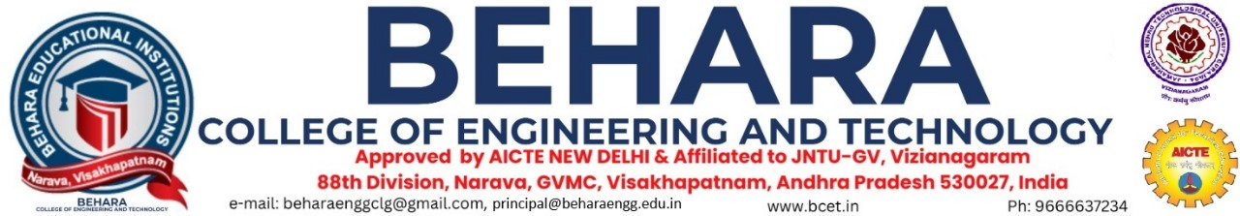



**INSTITUTION – INDUSTRY CELL**





* BCET's Institution – Industry Cell is established to synchronize the quality of éducation with industry needs and trends.
* This cell recognizes industry expectations and supports institutional readiness to address industrial demands by organizing sponsored projects, seminars, workshops, and various other training programs.
* The aim of the cell is to make an effective contribution to educational system identifying the gap between academic curriculum and need of the industry.
* The Institute aims to produce "Industry-Ready" students by implementing an effective IIC, ensuring they are employable.

**The activities of the IIC are:**

➢ To strengthen the relationship between industries and institutes as an ongoing interaction between the Industry and Institute is essential.

➢ It organizes symposiums, seminars, webinars and workshops by inviting the industry experts as resource persons to share the experience and expertise between institutions and industry for mutual benefits. This helps to integrate industrial training and other inputs to develop students.

➢ The IIC also arranges industrial visits, internships for students and guest faculty from industry experts.

➢ Industry Institute partnership reflects in equipping faculty to latest practices and makes the students industry-ready by providing exposure to current industry practices, and hones their skills to adapt changing technologies.

➢ The primary focus of IIC is to interact with elite industries and extend the efforts in establishing partnership with industries across the country in near future.

### **Members:**

|  |  |  |  |  |  |
| --- | --- | --- | --- | --- | --- |
| S.No | Name & Details | Department | Designation | Qualification | Roles |
| 1 | Dr. V Sridhar Patnaik | Mechanical Engineering | Principal | M.Tech.,Ph.D | Head of the Institution |
| 2 | Mr. Ch NarayanaRao | Computer Science and Engineering | Associate Professor | M.Tech.,(Ph.D) | President, IIP Cell |
| 3 | Mrs K S P Keerthi | Computer Science and Engineering | Assistant Professor | M.Tech.,(Ph.D) | Member |
| 4 | Mr G Srikanth | Electronics and Communications Engineering | Assistant Professor | M.Tech.,(Ph.D) | Member |
| 5 | Mr CH GovindaRaju | Electrical and Electronics Engineering | Assistant Professor | M.Tech.,(Ph.D) | Member |
| 6 | Mr V Anil Kumar | Electronics and Communications Engineering | Assistant Professor | M.Tech.,(Ph.D) | Member |

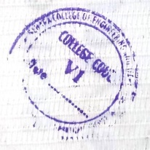

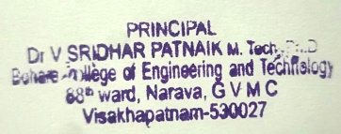

**Principal**