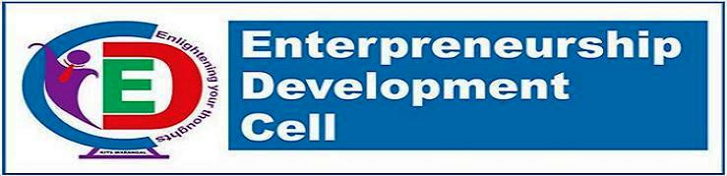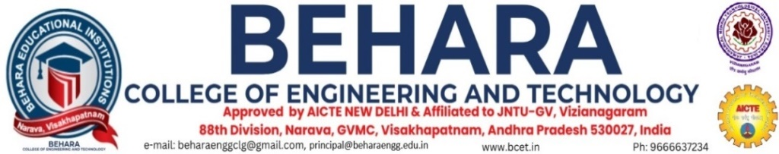

### ****Entrepreneurship Development Cell – EDC****

### The Entrepreneurship Development Cell (EDC) is a program designed to assist students, entrepreneurs, as well as Institute educators, with pre-venture, startup, or existing businesses with financial management, marketing, technology, product development, and commercialization issues. Innovation, entrepreneurship, and industry-academia collaboration can be promoted through an Entrepreneurship Development Cell (EDC) for an engineering college. EDCs are platforms for nurturing and supporting entrepreneurial talent among students and faculty.

**Objectives & Goal:**

Through entrepreneurship, innovation, and economic development, it will benefit the academic community and the broader region.

Entrepreneurial Development Cell reviews the progress of Entrepreneur activities. With a focus on incubating all feasible ventures through technology intervention, the cell aims to promote Techno-entrepreneurship more systematically and comprehensively.

• Promote entrepreneurship and innovation as career opportunities and instill skillsets required of young graduates.  
• To stimulate a better understanding of the Entrepreneurship life cycle and how students can create innovative products through the implementation of relevant methods.

**Dedicated Team:**

Faculty members, administrators, and enthusiastic students make up the team that runs the EDC. EDC activities will be planned and executed by this team.

### ****Role of the Cell Members:****

### **Fostering the entrepreneurial spirit in Students**

### **Creating awareness about Transfer of Technology.**

### **Encouraging entrepreneurs to promote Small & Medium Enterprises**

### **Report to the principal on significant matters.**

### ****Functions:****

### **To organize entrepreneurship awareness camps, entrepreneur programs faculty development programmes in the region for benefit of science and technology persons.**

### **To developed & introduce curriculums on entrepreneur development at various levels include graduation & post graduation of courses of parent institutional and others institution in the region.**

### **To conduct research for survey for identifying entrepreneur opportunities.**

### **To guide & assist prospective entrepreneurs on various aspects such as preparing the projects, reports, obtaining project approval loans, and facilities from agencies of support system.**

### **Organize guest lecture T.V & radio talks seminars etc., for promoting growth of science and technology based on execution of projects.**

### ****Members:****

|  |  |  |  |  |  |
| --- | --- | --- | --- | --- | --- |
| S.No | Name & Details | Department | Designation | Qualification | Roles |
| 1 | Dr. V Sridhar Patnaik | Mechanical Engineering | Principal | M.Tech.,Ph.D | Head of the Institution |
| 2 | Mr. Ch NarayanaRao | Computer Science and Engineering | Associate Professor | M.Tech.,(Ph.D) | President, ED Cell |
| 3 | Mrs K S P Keerthi | Computer Science and Engineering | Assistant Professor | M.Tech.,(Ph.D) | Member |
| 4 | Mr G Srikanth | Electronics and Communications Engineering | Assistant Professor | M.Tech.,(Ph.D) | Member |
| 5 | Mr CH GovindaRaju | Electrical and Electronics Engineering | Assistant Professor | M.Tech.,(Ph.D) | Member |
| 6 | Mr V Anil Kumar | Electronics and Communications Engineering | Assistant Professor | M.Tech.,(Ph.D) | Member |



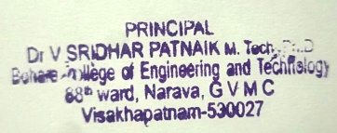

Principal