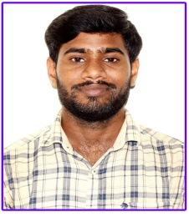

FACULTY PROFILE
Name | Chokkapu NarayanaRao
Date of Birth | 10th July 1991
BCET ID | BCET - T - 025
Vidwan ID | 171345(https://vidwan.inflibnet.ac.in/profile/171345)
Educational Qualifications | M.Tech.,(Ph.D)
Work Experience  - Teaching  - Research  - Industry  - Others | 10 Yr  NIL  01 Yr
Area of Specialization | Computer Science and Engineering
Courses taught at Under Graduate/ Post Graduate Level | Deep Learning Techniques, Big Data, Analytics,  Natural Language Processing, Unified Modeling Language, SPM, Software Engineering, Cloud Computing, Data Structures  Programming: C, Java
Research Guidance  - No. of papers published in National/ International Journals / Conferences | NIL
Projects carried out in B.Tech | 10
Projects carried out in B.Tech | 02
Patents | 03
Technology Transfer | NIL
Research Publications | SCOPUS - 02  UGC Care - 08
No. of Books published with details | NIL
No. of Online Courses with details | NPTEL -07 eDx - 05 Great Learning 05

