

Best practices -Mentoring

1. Title of the Practice: Mentoring

2. Objectives of the Practice

- The goal of a mentorship program is to accelerate the personal and professional development of mentees.
- This is achieved by providing mentees with guidance, advice and feedback from mentors with more experience than themselves.
- Prior to pursuing a mentoring relationship, it is beneficial to ponder Commitment, Dedication and clarity.
- To provide support and guidance on teaching, research, and mentoring of students.
- To support the professional advancement of the mentees by relaying experiences and knowledge of mentors in the key performance areas of teaching, research and support service.
- To address psychosocial issues of the mentees for in time remedy and to avoid things deteriorate further.
- To improve the study environment by improving relationships between teachers and their students and make the teaching more effective.
- The purpose of the exercise is to assess skills, strengths, weaknesses and areas where development is needed.
- To identify achievable learning goals.
- The plan requires following things:
Declaring personal goal
- The personal goal should identify the student’s values and vision inclusive of ethical considerations for personal and professional development.
- Self-assessment & Conversation Topics
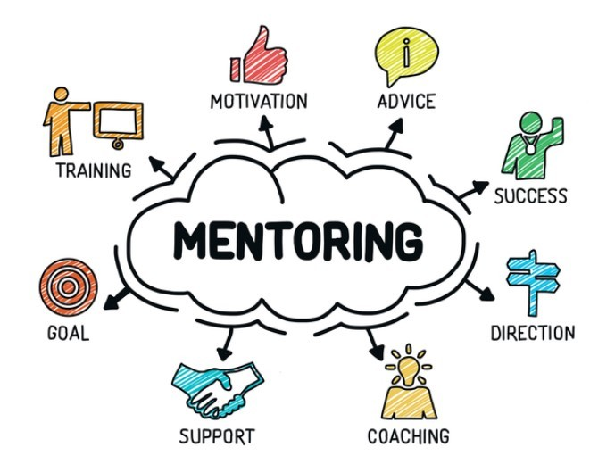

3. Challenges and issues in designing and implementation of this practice (Mention challenges encountered in your department)

There are several challenges involved in designing the structure of roles and responsibilities of the mentor-mentee scheme. The expectations from the mentor & mentee sometimes become roadblocks to the implementation.


Expectations from Both Mentor and Mentee
- Respect confidence and trust each other.
- Discover common ground and respect your differences.
- Be available as and when required with prior planning
Expectations from Mentee
- Identify realistic goals. Discuss your needs and expectations with your mentor; think about what you want out of the program prior to each meeting.
- Negotiate ideas and activities with your mentor.
- Be committed to carrying out agreed-upon goals; follow through.
- Be receptive to suggestions and feedback.
- Keep mentors informed of progress.
- Contact mentor if unable to attend scheduled meetings in a timely manner.
- Realize that having a mentor is a privilege and work hard to take advantage of the opportunity.
- Contact program staff if there is a concern with the mentor relationship.

4. Description of the Practice and its uniqueness in the context to indian higher education (Mention limitations /Constraints)

Mentor Duties

- Each mentor is allotted a batch of students, as suggested by the Departmental Coordinator in consultation with the Head of the Department.
- Mentors should conduct at least four meetings per semester with the mentees.
- Mentors should take care of the mentee's batch for academic interests and support them for improvement.
- Mentors should encourage students for extracurricular activities within the institute and at University as well as inter-University level.
- Mentors should interact with parents only in case of extreme situations.
- Mentors should maintain records of all the meetings held with mentees/ parents.
- Mentors should update the record regularly in the formats supplied.
- Mentors should provide information about possible financial assistance available to mentees.
- Every Department has to conduct an “Open House” once in an academic year.
- The record has to be handed over to the new mentor in case mentors are changed.
- Annual report in form of summary has to be prepared by each Mentor and to be submitted to the Departmental Coordinator.


5. Evidence of Success (Provide evidence of success such as performance against targets and benchmarks, review/results)

