Date: 30/08/2024
Place: Visakhapatnam
To
The Registrar,
JNTU-GV
Subject: Action Taken Report Regarding Anti-Ragging Activities
Respected Sir/Madam,
Behara College of Engineering and Technology (BCET), newly established and functioning academically since the academic year 2025–26, has taken proactive measures to prevent ragging and promote awareness among students and staff. We are pleased to report that no incidents of ragging have occurred on campus.
The following initiatives were undertaken as part of our anti-ragging efforts:
- Constitution of Anti-Ragging Committee
  - The committee has laid down policies and guidelines to ensure a ragging-free environment.
- Display of Anti-Ragging Posters
  - Posters were prominently placed in classrooms, library, canteen, and other circulation points to reinforce awareness.
- One-Day Workshop on Anti-Ragging
  - Conducted during the Induction Program to sensitize new students.
- National Anti-Ragging Week Activities (12th–18th August 2025)
- As per AICTE guidelines, the following events were organized:
- Orientation Program on Anti-Ragging (12th August)
- Poster Making Competition (13th August)
- Screening of Short Films and Reels on Anti-Ragging (14th August)
These activities were well-received and contributed significantly to fostering a safe and respectful campus culture.
We remain committed to upholding the values of empathy, dignity, and zero tolerance towards ragging.
Thanking you,
Yours sincerely,
Head of the Institution
Behara College of Engineering and Technology

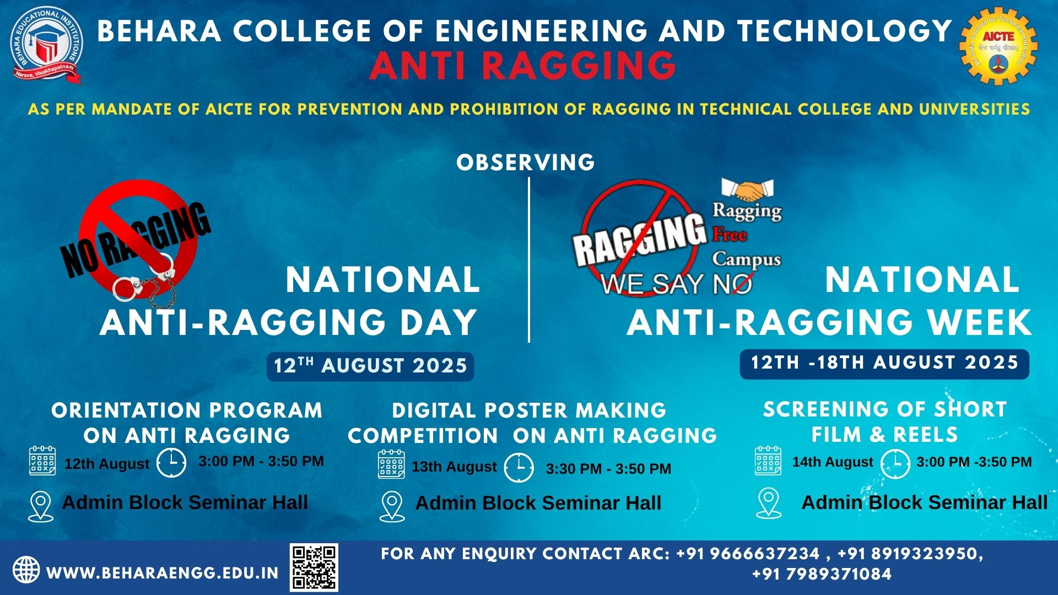

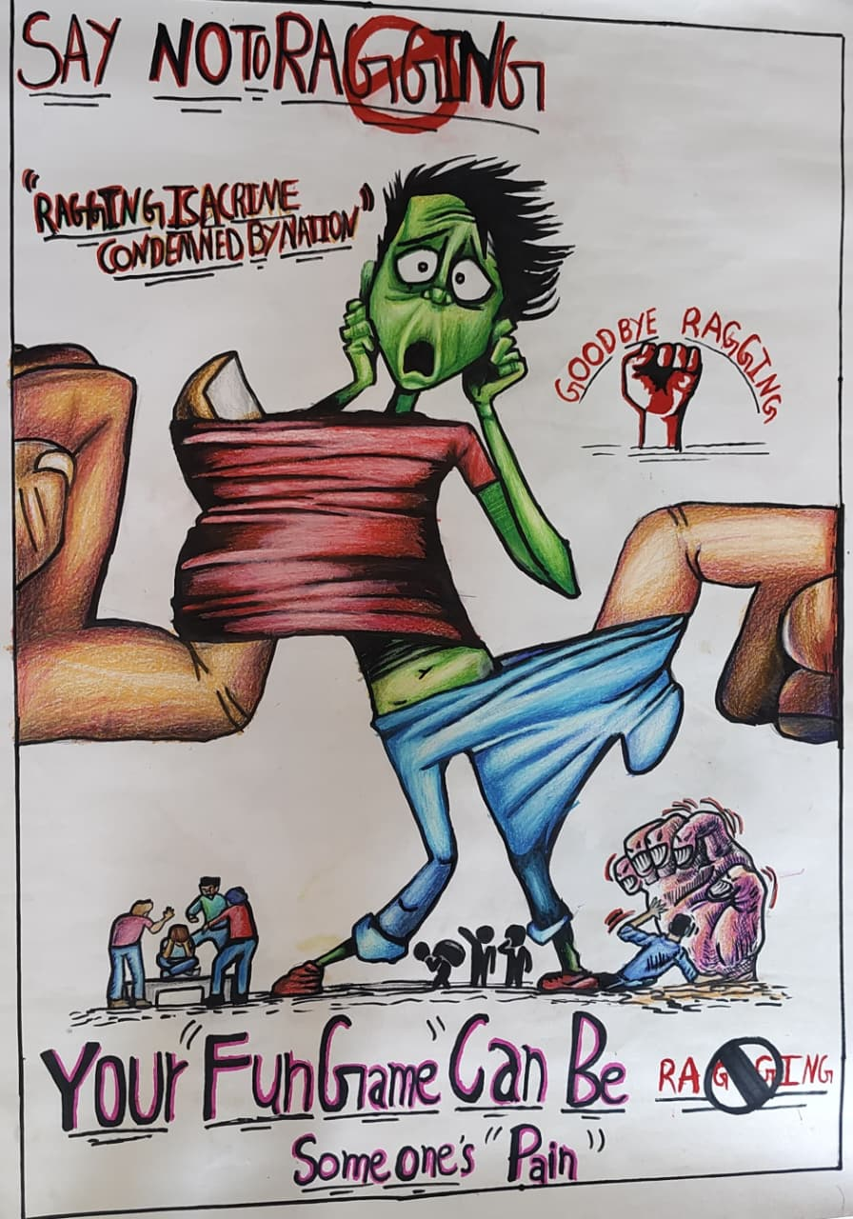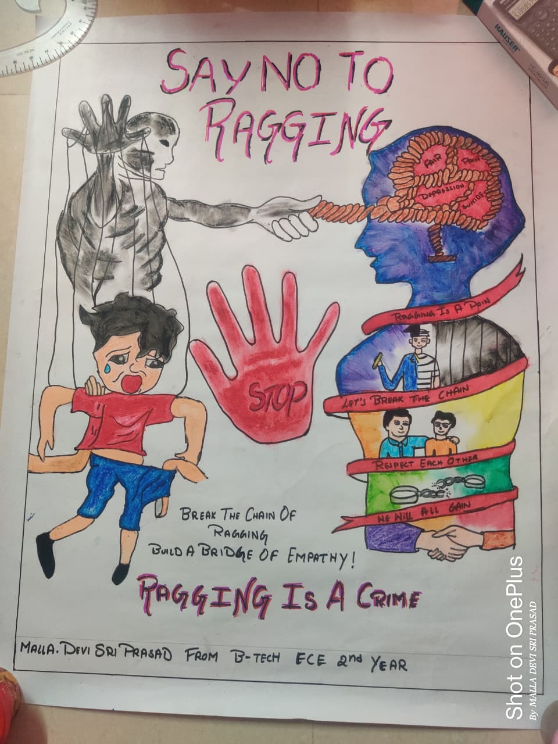
Poster-1 Poster-2

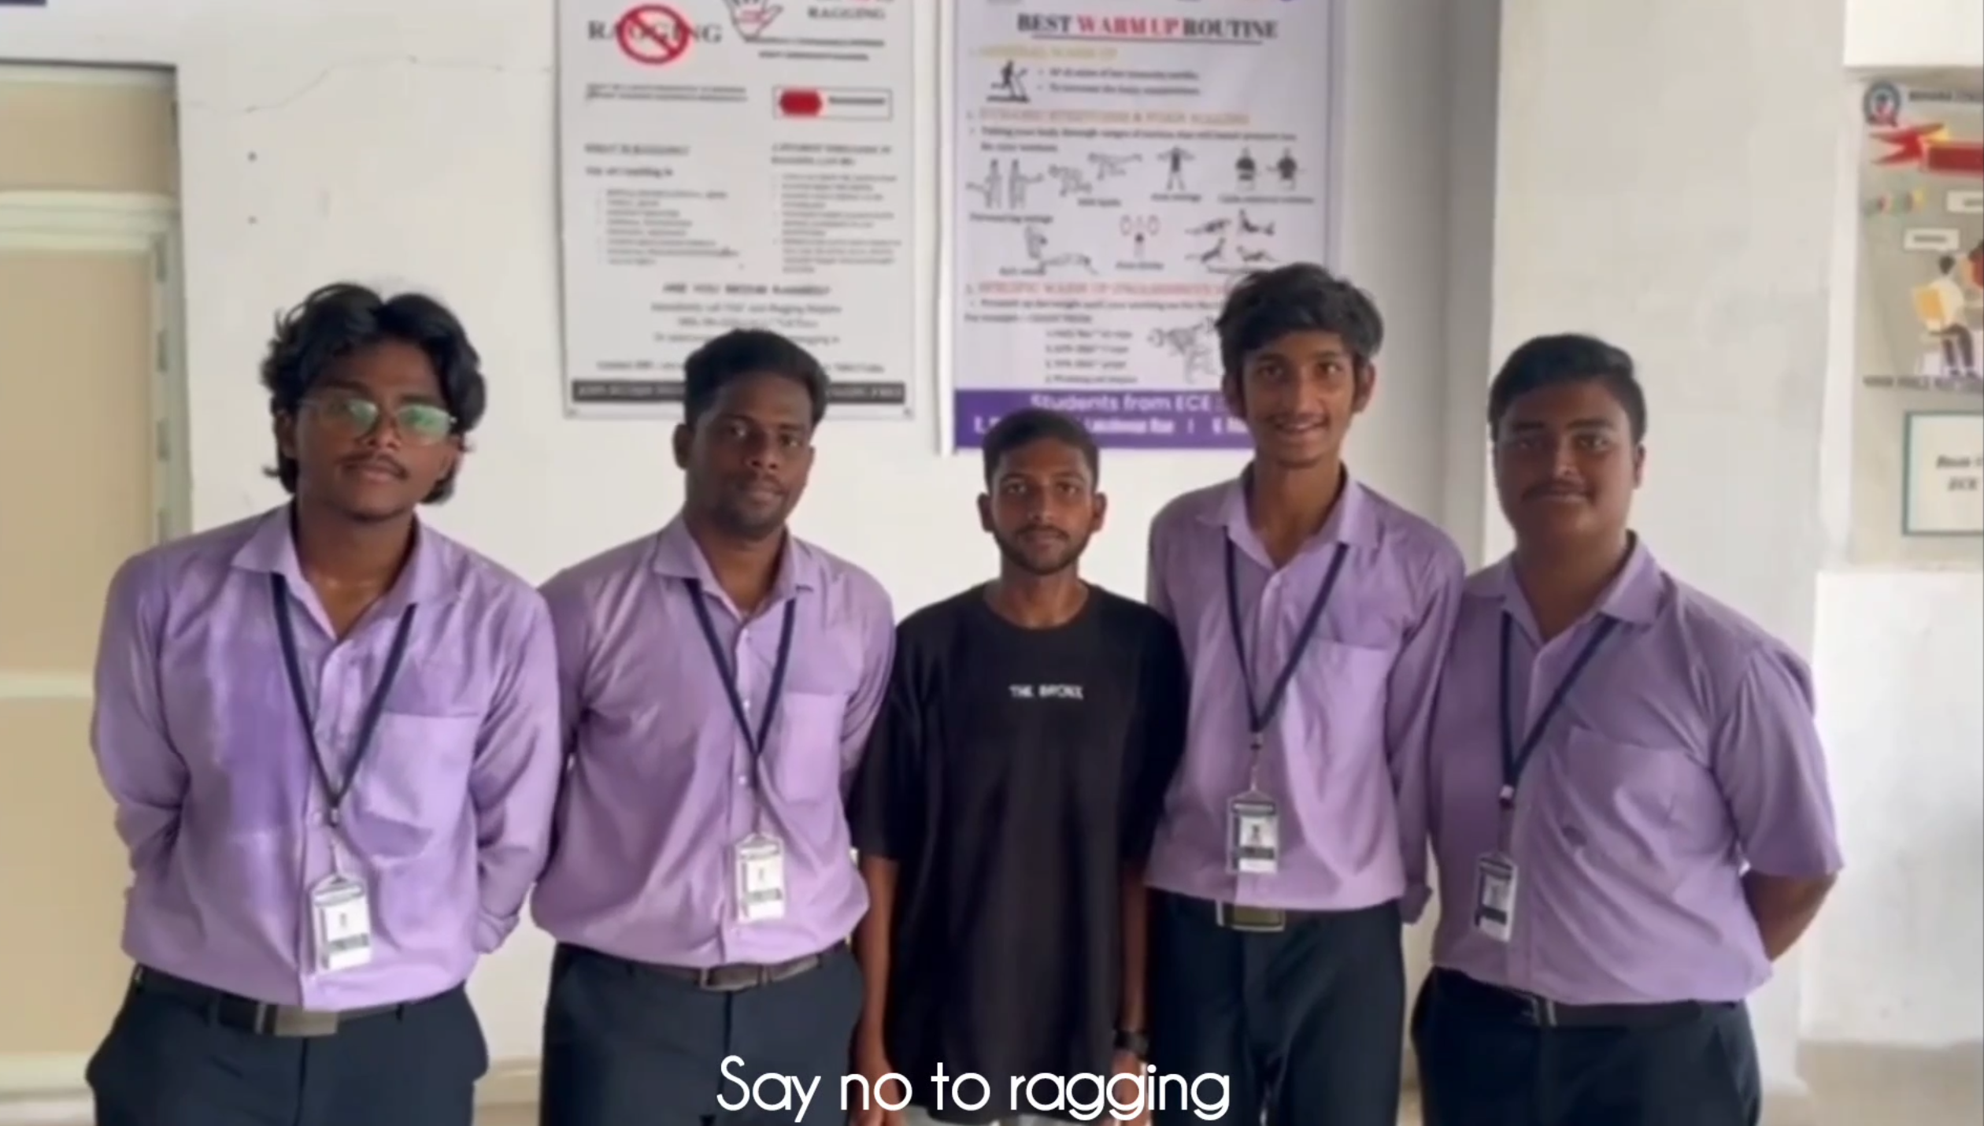

Video : Say No To Ragging

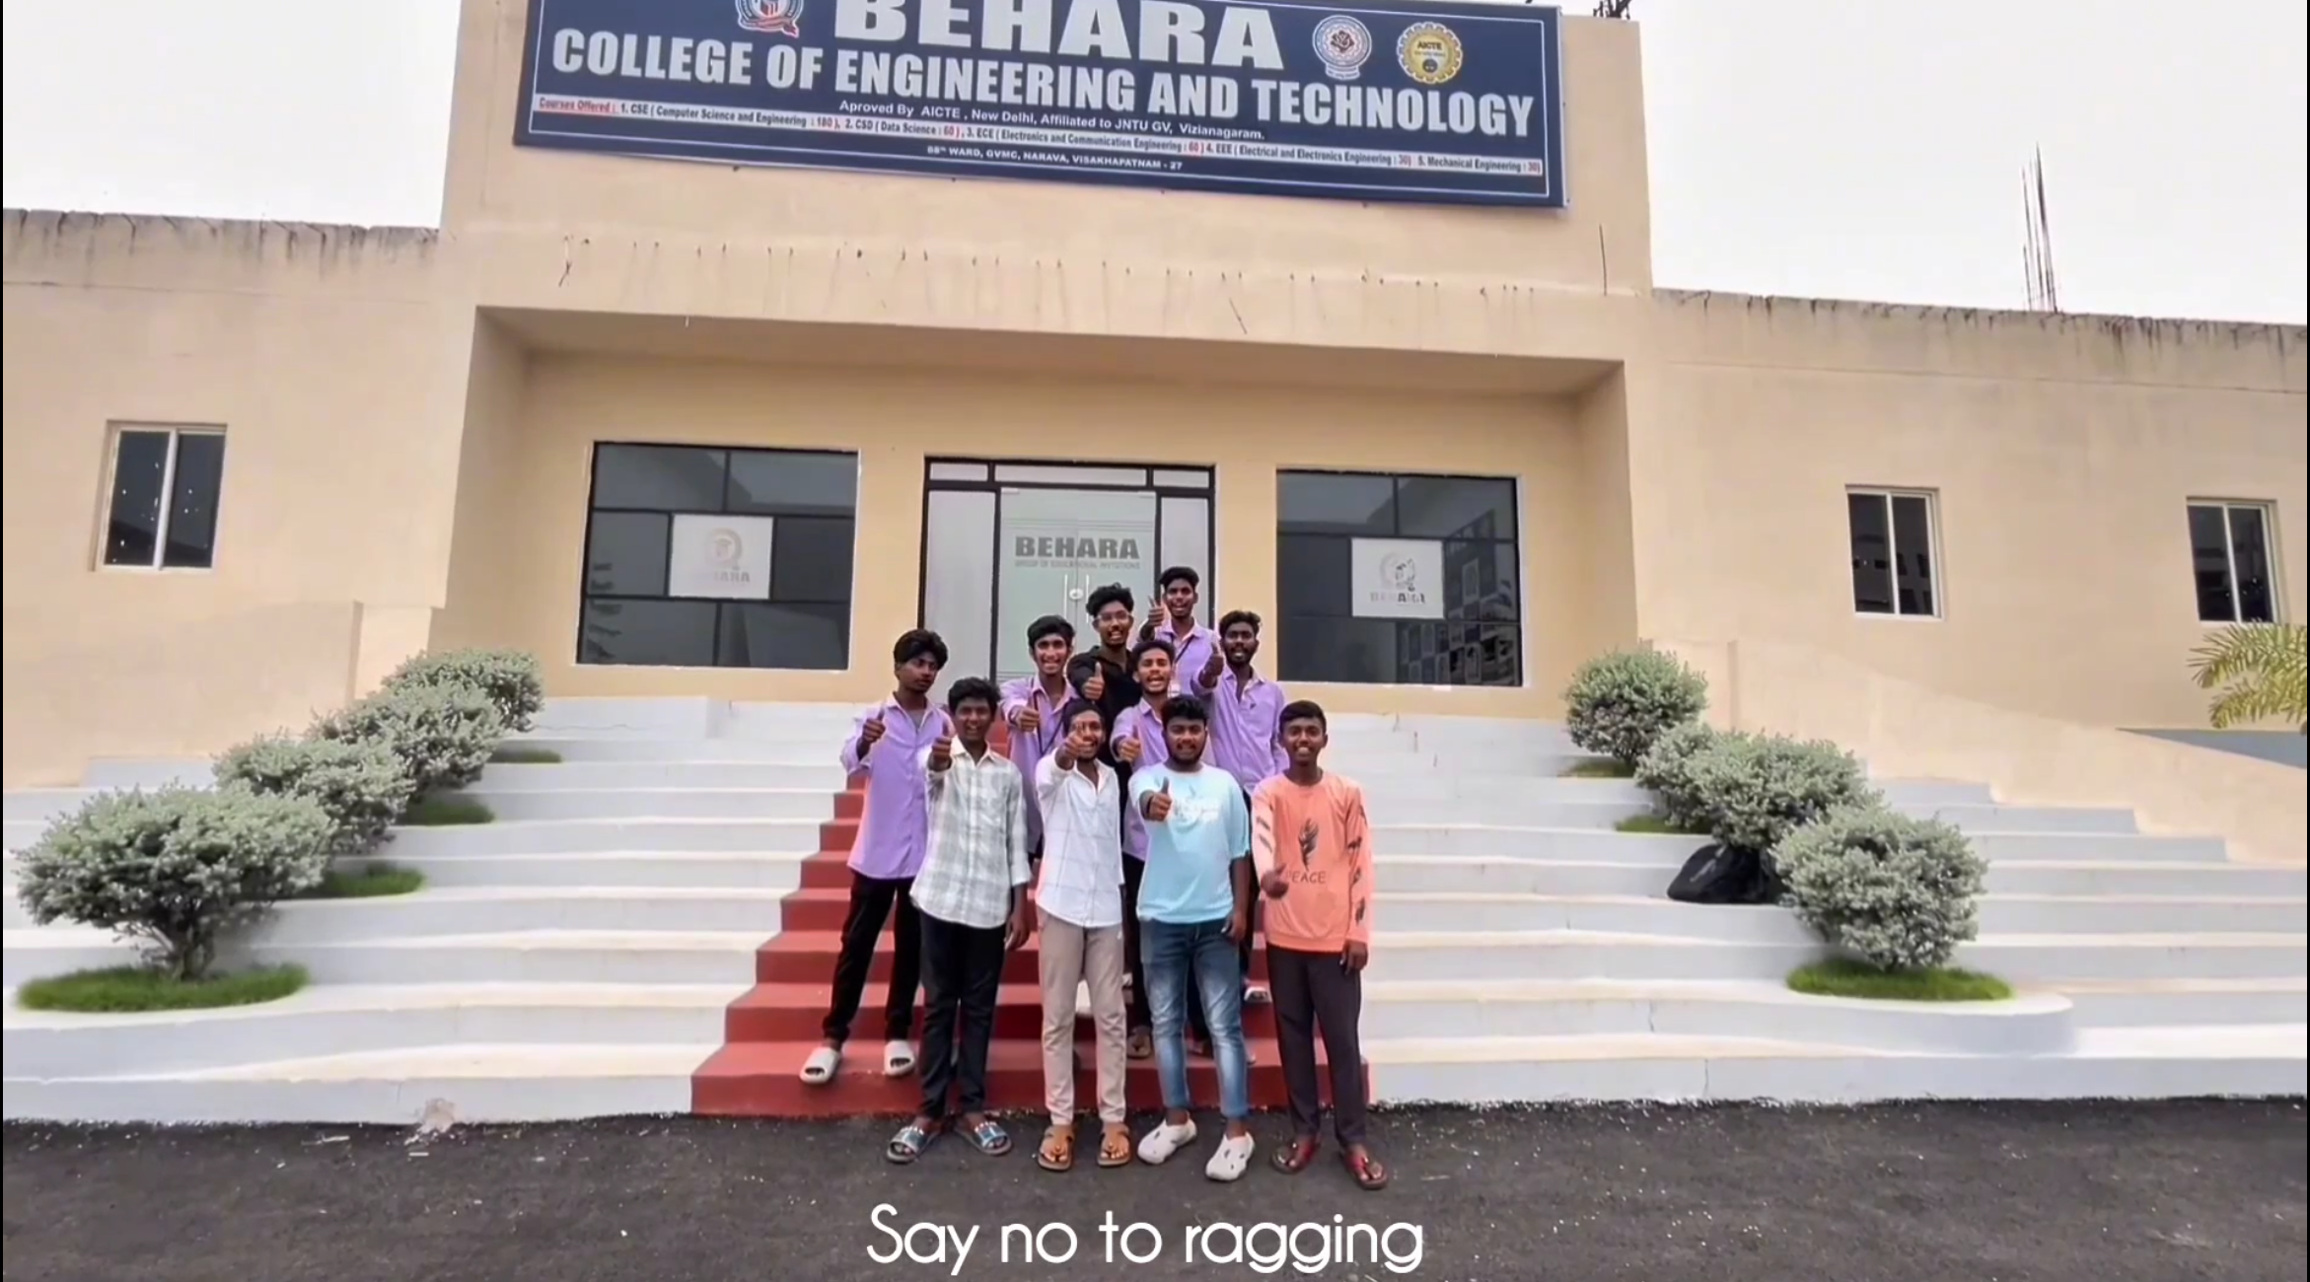

Video : Say No To Ragging

12.3 ANTI RAGGING COMMITTEE
Discipline and Anti-Ragging Committee
(2025-2026)

S.No | Name of the Committee members | Designation | Department | Mail id | Phone No.
1. | Dr.V.Sridhar Patnaik , Chairperson | Principal | Principal MECH | principal@beharaengg.edu.in | 9949638777
2 | Mr. G.Srikanth  Co-ordinator | Asst. Professor | HoD ECE | hodece@beharaengg.edu.in | 7989371084
3 | Dr.B.Devi , Member | Asso.Professor | HoD BS&H | hodbsh@beharaengg.edu.in | 9491580659
4 | Mr.CH.Narayan , Member | Asso.Professor | HoD CSE | hodcsecsd@beharaengg.edu.in | 9030176002
5 | Mr.CH.Govinda Raju, Member | Asst.Professor | HoD EEE | hodeee@beharaengg.edu.in | 9912040776
6 | Mr.D.Kiran Kumar, Member | Asst.Professor | HoD Mech | hodmech@beharaengg.edu.in | 8074780856
7 | Mrs.Y.Pavani, Member | Asst.Professor | BS&H | ypavani@beharaengg.edu.in | 9885968581
8 | Mr.A.Praveen, Member | PH.D | H&BS | pd@beharaengg.edu.in | 8886240330
9 | Mr.Rakshit Kumar Pandey, Member | Asst.Professor | Mech | rakshitpandey@beharaengg.edu.in
10,11 | Two parents, Members |  |  |  | 7842437646
10,11 | - G Raja Rao  - Y Mahesh |  |  |  | 6348759842
12,13 | Two Students from fresher | Students | I YR.Mech |  | 8019402261
12,13 | and senior, Members  i) D Siddartha | Branch | I YR.Mech |  | 8019402261

 | ii) B Renukha |  | II YR,CSE |  | 8328054864
14 | Mrs. G.Janaki | Mahila Police | Pendurthi  Police Station |  | 9885291889
Objectives and responsibilities of the Anti-Ragging Committee
- Inculcating Culture of Ragging Free Environment in the Campus.
- Engage in the works of checking places like Buses, Canteens, Classrooms and other places of student congregation.
- Involved in designing strategies and action plan for curbing the Menace of Ragging in the college by adopting array of activities.
- Conduct awareness programmes from time-to-time in the campus.
- To educate the students at large by adopting various means about the menace of Ragging and related Punishments there to. A gamut of positive reinforcement activities are adopted by Anti-Ragging Committee for orienting students and molding their personality for a better cause.

