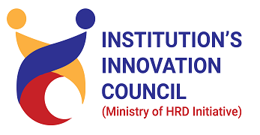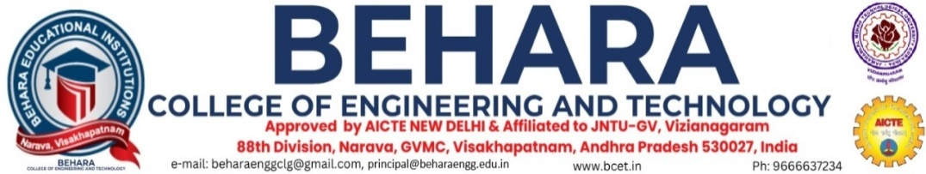

The Institution Innovation Council (IIC) promotes innovation, entrepreneurship, and collaboration within educational institutions, thereby increasing research and innovation in India. The Institution Innovation Council (IIC) was established in 2024 at Behara College of Engineering and Technology (V1) with some committee members to foster innovation, entrepreneurship, and collaboration among students, faculty, and industry partners. The initiative was launched by the **Ministry of Education (MoE)** under the **Government of India** as part of the **Atal Innovation Mission (AIM)**. The mission encourages the establishment of innovation and entrepreneurial ecosystems within educational institutions to nurture creativity and problem-solving skills among students and faculty.

**Major Focus:**

* To create a vibrant local innovation ecosystem.
* Start-up supporting mechanism in HEIs.
* Prepare institute for ATAL Ranking of institutions on innovation achievements framework.
* Establish function ecosystem for scouting ideas and pre-incubation of ideas.
* Develop better cognitive ability among students.

**Function of IIC:**

* To conduct various Innovations, IPR and entrepreneurship-related activities prescribed by MIC in time bound fashion.
* Identify and reward innovations and share success stories.
* Organize periodic workshops/ seminars/ interactions with entrepreneurs, investors, professionals and create a mentor pool for student innovators.
* Network with peers and national entrepreneurship development organizations.
* Create an Institution’s Innovation portal to highlight innovative projects carried out by institution’s faculty and students.
* Organize Hackathons, idea competition, mini-challenges etc. with the involvement of industries.

**Key Features:**

* **Student and Faculty Involvement**: Encourages active participation of both students and faculty members in innovation-related activities.
* **Government Schemes and Programs**: Leveraging government initiatives like Atal Tinkering Labs, Startup India, and other programs to support innovation.
* **Regular Monitoring and Evaluation**: IICs are periodically assessed based on their innovation and entrepreneurial activities, ensuring continuous improvement.

**Benefits:**

* **Enhanced Creativity**: Provides students with the opportunity to think creatively and develop innovative solutions.
* **Exposure to Industry**: Students gain insights into the real-world challenges and trends in industries.
* **Career Opportunities**: By fostering an entrepreneurial mindset, IICs open up avenues for students to create startups or join innovation-driven organizations.
* **National Recognition**: Institutions that excel in promoting innovation are often recognized at the national level by government bodies.

**Who can apply for IIC:**

Any Institute (HEIs) willing to establish IIC and meet any one of following criteria can establish IIC at their Institute.

* Having pre-incubation centres/incubation centers, student idea clubs.
* Participated in ARIIA Ranking.
* Participated in NIRF Ranking.
* NBA/NAAC Accreditation.
* Recipient of TEQIP –III fund & establishment of Start-up Cell.
* Government/ Government funded/Deemed University.
* HEIs offering non-technical programs can also establish IIC.

### ****Members:****

|  |  |  |  |  |  |
| --- | --- | --- | --- | --- | --- |
| S.No | Name & Details | Department | Designation | Qualification | Roles |
| 1 | Dr. V Sridhar Patnaik | Mechanical Engineering | Principal | M.Tech.,Ph.D | Head of the Institution |
| 2 | Mr. Ch NarayanaRao | Computer Science and Engineering | Associate Professor | M.Tech.,(Ph.D) | President, IIC |
| 3 | Mrs K S P Keerthi | Computer Science and Engineering | Assistant Professor | M.Tech.,(Ph.D) | Member |
| 4 | Mr G Srikanth | Electronics and Communications Engineering | Assistant Professor | M.Tech.,(Ph.D) | Member |
| 5 | Mr CH GovindaRaju | Electrical and Electronics Engineering | Assistant Professor | M.Tech.,(Ph.D) | Member |
| 6 | Mr V Anil Kumar | Electronics and Communications Engineering | Assistant Professor | M.Tech.,(Ph.D) | Member |





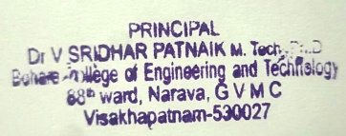

Principal