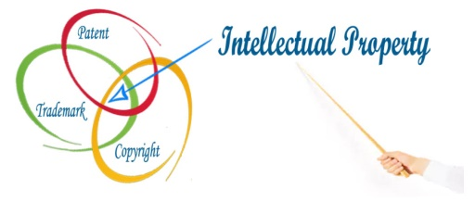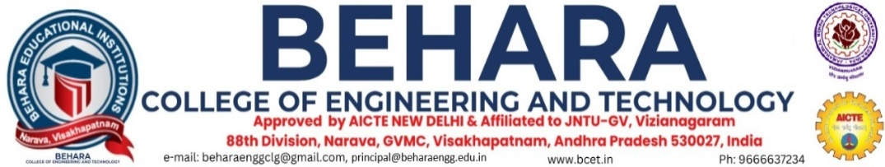

### ****INTELLECTUAL PROPERTY RIGHTS (IPR) CELL****

### A cell for intellectual property rights was established in this college in 2024. A successful position in the technological world is largely determined by intellectual property rights (IPR). In the 21st century, technological advances have transformed most wealth-creating work from physical to knowledge-based. Organizations will face a major challenge in the coming years when it comes to creating a culture of intellectual property protection.

### This can be achieved by creating a stringent IPR regime. Among the state's engineering colleges are its richest sources of intellectual capital. A lot of innovative ideas, inventions, and technologies are coming out of engineering colleges. Many of these inventions, however, are not protected by patents because of a lack of awareness of intellectual property rights.

### The cell is committed to organizing multiple ****Intellectual Property Rights (IPR) awareness seminars**** in the future to highlight the significance of IPR among students and faculty. These initiatives aim to enhance awareness, foster innovation, and equip the academic community with essential knowledge about intellectual property protection. The cell provides necessary guidance to the students and faculty members to patent their valuable inventions

**Objectives**

* The purpose of this program is to create awareness about IPR among the faculty and students of the institution.
* To impart training on future endeavors regarding patent filing processes, procedure of IPR, screen projects, make drafts and file patents to the competing authority.
* Conducting workshops, seminars, and training courses on intellectual property rights.
* In order to promote a better understanding of intellectual property rights.
* Students and faculty should be encouraged to work on patentable projects.
* Identification of prospective inventions, innovations, and ideas for improvement of service.
* Identify and recommend inventions that can be converted to patents/copy rights.
* Incentives should be provided to inventors in order to encourage innovation.
* Promoting technology advancements for improved quality of life and environmental protection.

### 

### ****Members:****

|  |  |  |  |  |  |
| --- | --- | --- | --- | --- | --- |
| S.No | Name & Details | Department | Designation | Qualification | Roles |
| 1 | Dr. V Sridhar Patnaik | Mechanical Engineering | Principal | M.Tech.,Ph.D | Head of the Institution |
| 2 | Mr. Ch NarayanaRao | Computer Science and Engineering | Associate Professor | M.Tech.,(Ph.D) | President, IPR Cell |
| 3 | Mrs K S P Keerthi | Computer Science and Engineering | Assistant Professor | M.Tech.,(Ph.D) | Member |
| 4 | Mr G Srikanth | Electronics and Communications Engineering | Assistant Professor | M.Tech.,(Ph.D) | Member |
| 5 | Mr CH GovindaRaju | Electrical and Electronics Engineering | Assistant Professor | M.Tech.,(Ph.D) | Member |
| 6 | Mr V Anil Kumar | Electronics and Communications Engineering | Assistant Professor | M.Tech.,(Ph.D) | Member |

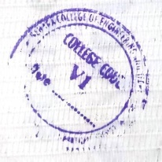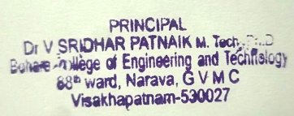

Principal